Policies and Procedures

Budget Procedures September 2007 (Revised September 7, 2017) (Revised April 21, 2021)
TABLE OF CONTENTS

1.0 Definitions 3
2.0 Responsibilities……………………………………………………………………….9
3.0 Budget Development Process
3.1 Development of the Legislative Budget Request ……………………………...11
3.2 Operating Budget Development Process ……………………… ………………11
3.3 Loading/Posting Budget into PeopleSoft ...……………… ……………………14
3.4 Positions, Rates and Salaries and Benefits Maintenance and Control………… 15
3.5 Budgeting of Carry Forward ...………………………………………………….18
3.6 Submission of the Operating Budget to the Board of Governors………………18
3.7 Educational and General (E&G) Cash Distributions… ……………………….23

4.0 Budget Amendments /Transfers
4.1 Budget Amendments 24
4.2 Budget Transfers 24

5.0 Budget Reporting/Monitoring
5.1 Quarterly Reporting/Monitoring 25
5.2 Monthly Reporting/Monitoring 26
5.3 Budget Checking 27

6.0 Submissions to the Board of Governors

6.1 Operating Budget Files and Manual Exhibits and Schedules 27
6.2 Expenditure Analysis File 27
6.3 Salary Category Detail Files 28
6.4 Other Reports/Special Projects 29

7.0 Appropriated Salary Increases ………………………………………………………. 29

Exhibits
Exhibit A Budget Calendar 31
Exhibit B Budget Transfer and Amendment Form 34
Exhibit C Board of Trustees Policy# 2005-02 Financial Administration 35
Exhibit D Board of Trustees Policy # 2005-05 Preparation and Submission of Budget 36 Exhibit E Statutes Relating to the Operating Budget Process 37

Definitions

    - Account – a PeopleSoft chart field that is designed to track revenues, expenditures, assets, liabilities and net assets.

    - Account Tree – the PeopleSoft system graphical hierarchy which displays the relationship between all accounting units and determines roll-up hierarchies.

    - Activity and Service Fees – each university, and university campus, is authorized by the Board of Governor’s rule to charge its students this fee as a component of the mandatory fee schedule. The level of the fee varies by university, depending on the purposes and programs for which it is intended to support.

    - Administrative Direction & Support Service - This activity center consists of all activities established for the central administrative operations, services, and functions of the institution as well as those activities related to personnel records for the faculty and staff. Excluded are those activities that relate to student admissions and records.

    - Allocation Summary and Workpapers – is a document which contains the allocation of resources to the eleven universities in accordance with the General Appropriations Act, the Implementing Legislation Bill, and the Legislative Appropriation Work papers.

    - Annual Salary Rate – is the salary to be paid a position on an annualized basis.

    - Appropriation – is the legal authorization to make expenditures for specific purposes within the amounts authorized in the appropriations act.

    - Appropriations Act – the fiscal authorization by the Legislature, based upon legislative budgets for the expenditure of amounts of money by an agency for stated purposes in the performance of the functions it is authorized by law to perform.

    - Auxiliary Trust Fund – is a budget entity which is comprised of ancillary support units such as the bookstore, food service, and parking services. Revenue is derived from auxiliary operations other than athletics and housing.

    - Black Male Program - The Black Male College Explorers Program is an at-risk prevention/intervention program designed specifically to prevent black males from dropping out of high school; facilitate their admission to college; and significantly increase their chances of earning a college degree.

    - Budget Amendment – is a budget transaction that changes the bottom line of a designated revenue or expenditure budget. Approval must be granted by the Board of Trustees before the Budget Office can input amendments into the financial system.
3

    - Budget Check – is the process that ensures that commitments and expenditures do not exceed total budgets.

    - Budget Control – is an option to enforce budgetary control at a specific level by restricting activity to the budgeted amount.

    - Budget Entity – is the level at which funds are specifically appropriated in the appropriations act.

    - Budget Transfer – is an internal budget transaction where funds are transferred or converted between departments or summary accounts. This transaction does not change the bottom line revenue or expenditure budgets. Approval from the Vice President is needed to process this request.

    - Carry-forward – Pursuant to Section 1011.45, Florida Statues “Unexpended amounts in any fund in a university current year operating budget shall be carried forward and included as the balance forward for that fund in the approved operating budget for the following year”. These funds are non-recurring and may be used for all legitimate non-recurring needs of the department. Current year budgets and carry-forward are maintained in separate funds, 101 and 120, respectively.

    - Certified forwards - are encumbrances and commitments against the approved budget which have not been paid/finalized prior to June 30.

    - Commitment Control – a PeopleSoft sub module that controls various financial activities based on available budget or other budget rule sets, and is often referred to as KK.

    - Contracts and Grants – is a budget entity which is comprised of three funds: Grants and Donations, Sponsored Research and the Developmental Research School. This budget entity contains activities in support of research; public service and training are funded with awards from federal, state, local and private sources.

    - Debt Service- the expenditure category used to pay the amounts due on any state debt or obligation for interest, any maturing principal, any required contributions to an amortization or sinking fund for a term debt or obligation, and any other continuing payments necessary or incidental to the repayment of a state debt or obligation.

    - Department – a PeopleSoft chart field that tracks academic or administrative units with FAMU’s organizational hierarchy. This is also the lowest level of accumulation for preparing the University’s operating budget, such as the President’s Office, Budget Office, Controller’s Office, Biology Department, etc.

- Education and General Fund - Appropriations and tuition revenues funds the general instruction, research and public service operations of the universities.
4

Release is the transfer of cash to the University from the State Treasury and the authority to spend the funds. These funds are released periodically, primarily in relation to State revenue collections during the year. Releases of E&G funds are provided by the State twice per month, generally based on 1/24 of the budget for each release.

- Educational Enhancement Trust Fund – are lottery receipts that are disbursed from the Florida Department of Education to the University monthly beginning in November or each year.

- Expenditure – is the creation or incurrence of a legal obligation to disburse money.

- Expenditure Analysis – is a document which reports the actual expenditures (fiscal and personnel) for the fiscal year ending the previous June 30 and includes total expenditures from all sources and distinguishes costs for master’s and doctoral programs as well as direct, indirect and full cost data.

- Expense – is an expenditure category that covers such items as supplies of a consumable nature, fixed charges, current obligations, commodities, etc.

- FAMU Developmental Research School (DRS) Trust Fund – state revenues dedicated to the Developmental Research School and received throughout the year from the Florida Education Finance Program (FEFP).

- Fiscal Year – is the period of time beginning July 1 and ending on the following June 30, both dates inclusive.

- Full-Time Equivalent (FTE) – a numerical designator for an appointment based on 100% for full time (40 hours). An FTE for a full-time employee is 1.00. A part- time employee FTE is calculated based on the proportion of number of weekly hours worked to 40.

- Fund – an accounting entity established for the purpose of conducting specific activities or attaining certain objectives in accordance with special regulations, restrictions, or limitations. Fund is also a cash account which receives monies from designated sources such as the General Revenue Fund – state revenues; Educational Enhancement Trust Fund – lottery receipts; and Student Fee Trust Fund- receipts from designated sources such as student fees, etc.

- Fund Balance – the year end result obtained from subtracting your total expenditures from total revenues.

- General Revenue – are state revenues which are received on a pro-rata basis throughout the year.

- Grants & Donations Trust Fund – non-governmental contracts and grants received throughout the fiscal year.

- Instruction & Research – this program consists of instructional program elements operating during the standard academic term (as defined by the institution) that are part of a formal degree or certificate curriculum and are managed by the regular academic departments.
- Institutes & Research Centers - This program consists of all those research- related activities that are part of a formal research organization typically created to manage a number of research efforts.

- Intercollegiate Athletics – is a budget entity that is funded from revenues derived from the student athletic fee that each university is authorized to collect as a component of the mandatory fee schedule. Revenues collected from the University’s athletic events, including concessions at athletic events are also sources of funding for Athletics. These revenues and expenditures are received and/or incurred on a seasonal basis, primarily during the football season.

- Libraries - This program includes those activities that directly support the collection, cataloging, storage, and distribution of published materials primarily in support of the institution's academic programs.

- Library Resources – is a special expenditure category for the purchasing of books and periodicals for the university’s libraries.

- Local Funds include the following university activities:

- Student Activities - Supported primarily by the student activity and service fee and funds operations of the student government, cultural events, organizations, and intramural/club sports.

- Financial Aid - This activity represents the financial aid amounts for which the university is fiscally responsible. Examples include: scholarships, student financial aid fee, bright futures and, federal grants.

- Concessions - These resources are generated from various vending machines located throughout the university campuses.

- Athletics - Revenues are primarily derived from the student athletic fee, ticket sales, and sales of goods.

- Man-Years (Person Years) – a budgeting term calculated and based on a position budgeted for twelve months of activity and a full-time portion of effort (weeks budgeted multiplied by FTE, divided by the actual number of weeks in the fiscal year (52.20).

- Museums - This program includes those activities related to collection, preservation and exhibition of historical materials, art objects, scientific displays, and so forth primarily in support of an institution's academic progress.

- nVision – Peoplesoft’s financial reporting tool which integrates the power of PeopleSoft Financials database and the flexibility and familiarity of Microsoft Excel.

- Operating Budget – an expenditure plan developed for each fiscal year. The plan must conform to the annual allocation/appropriation and list estimated expenditures by budget category for the fiscal year.

- Operating Capital Outlay – is the expenditure category which includes equipment, fixtures and other tangible personal property on a non-consumable and nonexpendable nature, the value or cost of which is $ $5,000 or more and the normal expected life is 1 year or more, and hardback covered bound books, the value or cost which is $100 or more.

- Other Personal Services – is an expenditure category which includes the compensation for services rendered by a person who is not regular or full-time filling an established position. This definition includes, but is not limited to services or temporary employees, student or graduate assistants, and consultants.

- Out of State Waivers – using the student fee formula and calculating the across the board percentage increase used by the legislature, the waivers are generated. The BOT is authorized to waive fees for purposes that support and enhance the mission of the university.

- Plant Operation & Maintenance - this category includes activities necessary for the general management and administration of all functions under the jurisdiction of the Physical Plant Division unless the activity is predominantly related to another subcategory. The section should generally be used to collect all costs associated with the director's/assistant director's offices of the division.

- Position Number – is an eight-digit unique number identifying the budgeted salary rate and FTE which is assigned to a position for the fiscal year.

- Program – defines groups or related activities, cost centers, revenue centers, responsibility centers and/or academic programs. Also defined as the classification of programmatic objectives associated with the account/department where funds are budgeted or compensation is drawn.

- Public Service - This program includes those services established and maintained by the institution to provide services to the general community or special sector within the community. The primary intent of establishing these programs is to

provide services that are beneficial to groups and individuals outside of the institution.

- Rate – is a term designated to mean the recurring salary allocation for a position.

- Risk Management – is a special expenditure category where the casualty insurance premiums are remitted to the Division of Insurance based on invoices that are received by the university.

- Salaries and Benefits – is the rate of pay plus benefits earned by employees.

- Salary Incentive - These funds are used to provide for the salary structure and salary incentive payments for full-time officers who have a community college or bachelor’s degree.

- Sponsored Research Trust Fund – total revenue received from state and federal contracts and grants throughout the fiscal year. .

- Student Services - Services and programs which enhance the educational environment of the campus as measured by availability of counseling and health services, student activities, orientation programs and other associated programs and to provide administrative services and to initiate, maintain and preserve the official academic record of each student.

- Tuition and Fees – revenue received from students at enrollment and accrued at a rate of approximately 40%/40%/20% (Fall, Spring and Summer) during the fiscal year.

- Tuition Differential Fee- This new fee has been approved by the Board of Trustees in accordance with state regulation 1009.24.13.s. This fee applies to all undergraduate students (or graduate students if enrolled in an undergraduate class) who begin enrollment after 7/2007 (exception - students who have Florida Pre-Paid Tuition plan active as of 7/1/2007)

- Technology Fee- This new fee has been approved by the Board of Trustees in accordance with state regulation 1009.24.13.s. A technology fee of up to 5 percent of the tuition per credit hour, beginning with the fall term of the 2009- 2010 academic year. The revenue from this fee shall be used to enhance instructional technology resources for students and faculty. The technology fee shall not be included in any award under the Florida Bright Futures Scholarship Program.

Responsibilities

Chief Financial Officer (CFO) and Vice President for Finance and Administration oversees the fiscal affairs for the University. The VP for Finance and Administration reports directly to the President.

University Budget Office reports to the Chief Financial Officer/Vice President for Finance and Administration and is responsible for the following functions:

- Development of an annual plan for the allocation of all university resources as approved by the President.

- Preparation of the annual Legislative Budget Request pursuant to the Board of Governors Policy Guidelines, the Board of Trustees priorities and the strategic priorities established by the President and Cabinet.

- Review and analysis of budget transfers to ensure compliance with University and State guidelines.

- Preparation of various reports that are submitted to the Board of Governors, the Board of Trustees, the University Budget Council and other agencies related to the University’s budget.

- Preparation of various special analyses to support operating and legislative budget programs.

- Serve as staff to the University Budget Council.

- Monitor budget, revenue and expenditures.

- Coordinating with the Controller’s Office the transfer of all revenues (i.e.
Administrative Expenses, Facility Maintenance and Equipment Reserve, Mandatories)

- Meet quarterly with the vice presidents and their fiscal representatives to review revenues and expenditures and discuss other fiscal issues. From April through June meetings will take place as needed.

- Host at workshops annually for all stakeholders.

Managers/Department Heads/Deans/Directors oversee and are in charge of their budgets on a day-to-day basis. They report directly to their respective Division Heads. Each department has a fiscal representative that is responsible for monitoring the budget, revenue and expenditures of their respective areas.

Division Stakeholder/Vice Presidents (VPs) are the ultimate responsible parties for the departments that fall in their divisions. They submit their budget data to the Budget Office.

Each division has a fiscal representative that is responsible for monitoring the budget, revenue and expenditures of their respective areas.

University Budget and Planning Council (UBPC) facilitates the effective planning, budgeting, and allocation of the University’s resources to accomplish the goals and objectives of the University’s Strategic Plan and makes associated recommendations to the President.

The composition of the UBPC is as follows:

Provost/VP, Academic Affairs, Co-Chair
VP/CFO, Finance & Administrations, Co-Chair
VP, University Advancement
VP, Strategic Planning, Analysis and Institutional Effectiveness
VP, Student Affairs
Associate VP/Chief of Staff, Finance & Administration
Assistant VP/Controller, Finance & Administration
Associate Provost, Student Success & Strategic Initiatives
Associate Provost, Faculty Affairs & Academic Initiatives
Associate Provost, Academic Affairs & Student Services
Assistant VP, Fiscal Management
Dean, College of Social Sciences, Arts & Humanities
Senator, Faculty Senate
Senator, Faculty Senate
Director, University Budget Office

The specific responsibilities of the UBPC includes:

- Recommending the annual distribution of resources to the various divisions based on: (1) the annual strategic priorities set by the President and Cabinet and (2) the relevant institutional data, assessments in accordance with Board of Trustees Policy Number 2008-02, and evaluations
- Recommending annual expenditure caps for the University
- Establishing annual set asides to ensure strategic priorities are accomplished
- Establishing timelines for the various University budget activities
- Routinely monitoring resource allocation and recommending changes as necessary
- Handling other resource allocation issues as assigned by the President
- Maintaining minutes of each meeting held
- Overseeing the University’s institutional effectiveness

3.0 Budget Development Process

3.1 Development of the Legislative Budget Request (LBR)

The LBR is developed based upon the Board of Governors (BOG) policy guidelines, the Board of Trustees priorities and the strategic priorities established by the President and Cabinet. The following represents the timetable for submission of the LBR for the operating budget.

- March: | Board approves the LBR Policy Guidelines.
- May: | Universities submit LBR issues as a component of the work plans.
- June: | Board reviews university work plans in which goals, initiatives, and financial assumptions are aligned with submitted LBR issues.
- July – Aug: | Chancellor works with universities to develop any system and university LBR issues.
- September: | Board approves the operating LBR.
- October: | Operating LBR is submitted to the Governor and Legislature.
- January: | If necessary, potential amendments will be considered.

Operating Budget Development Process

In accordance with BOT Policy 2005-05, Preparation and Submission of the Budget, the University Board of Trustees (BOT) annually adopts an operating budget. Board of Governors’ instructions provide the budget entities to be included in the annual operating budget.

- Educational and General (E&G)- The Education and General budget funds the general instruction, research, and public service operations of the universities.

- The Contracts and Grants budget contains activities in support of research, public service, and training.

- The Auxiliary Enterprises budget contains activities for ancillary support units on each university campus. Some of the major activities include housing, food services, book stores, student health centers, facilities management, and computer support.

- Student Activities – This budget entity contains activities supported primarily by the student activity and service fee and funds operations of the student government, cultural events, organizations, and intramural/club sports.

- Financial Aid – The activity in this budget entity includes the financial aid amounts for which the university is fiscally responsible. Examples include: student financial aid fee, bright futures, federal grants, college work study, and scholarships.

- Concessions – The activity in this budget entity is funded from resources generated from various vending machines located on the university campuses.

- Athletics –The activity in this budget entity is funded from revenues derived primarily from the student athletic fee, ticket sales, and sales of goods.

- Technology fee – The activity in this budget entity is funded from collections used to enhance instructional technology resources for students and faculty. This fee is authorized by Florida Statutes, Section 1009.24(13).

- Board-Approved Fees – This activity is funded from student fees proposed by each university and authorized by the Board of Governors to address specific student-based needs not addressed through another service or fee. For Florida A&M University this fee is the College of Law Bar Review Preparation Fee.

Each year the university provides a set of operating budget request instructions that includes forms for departments to use to prepare budget requests.

The University has established a Budget Calendar that outlines the key activities related to the integrated planning and budgeting process. Listed below is a summary of activities. Please refer to Exhibit A for a copy of the Budget Calendar.

- January: The President and Cabinet will identify the University’s strategic priorities.
- February: Once those priorities are identified, the Budget Office prepares annual Operating Budget policy guidelines for all university budgets. These policy guidelines are distributed by the CFO.

- March: All Operating Budget Requests are due to the Budget Office.

- April: The UBPC will conduct Budget hearings and recommend the annual distribution of resources to the various divisions based on: (a) the annual strategic priorities set by the President and Cabinet (b) Legislatively earmarked funding and (c) the relevant institutional data, assessments, and evaluations.

- May: The President approves all of the preliminary Operating Budgets. The Budget Office prepares the Preliminary Operating Budget by budget entity for the President to present to the Budget and Finance Committee for approval. Upon the approval of the Budget and Finance Committee, the President presents the budgets to the BOT for adoption.

- June: The BOT adopts the University’s Operating Budget for the next fiscal year. This preliminary operating budget is submitted to the Board of Governors.

- July: The preliminary University operating budget for the upcoming fiscal year is made available in People Soft.

- August: The Budget Office submits the operating budget to the Board of Governors as described in Section 3.7.

- September: The Board of Governors approves of operating budgets for the SUS.

OVERVIEW OF CURRENT BUDGET PROCESS

The University uses the University Budget Council for oversight of the budget management process. The University Budget Council is responsible for the facilitation of effective planning, budgeting, and allocation of the University’s resources to accomplish the goals and objectives of the University’s Strategic Plan and makes associated recommendations to the University President.

Through the University Budget Council specific responsibilities, the recommending body will ensure that all budget and reinvestment/reallocations are in alignment with the University’s strategic plan, annual strategic priorities and unit internal priories identified through divisional planning that are in alignment with University’s strategic plan.

The Council will make recommendations to the President’s Senior Leadership Team for proposed base budget and reinvestment/reallocations. The University is aware that the funding priorities identified may exceed the amount of available reinvestment revenues.

Allocation of Funds

- Pursuant the University Budget Office Policies and Procedures 3.2, the University senior leadership in conjunction with the Board of Trustees will identify annual strategic priorities. These priorities are in alignment with the University’s mission, 2017-2022 Strategic Plan, and Board of Governors strategic plan and initiatives. Units are provided with these priorities in January of each fiscal year to prepare their budget requests in accordance with the University’s six strategic priorities:

  - Exceptional Student Experience
  - Excellent and Renowned Faculty
  - High Impact Research, Commercialization, Outreach and Extension Services
  - Transformative Alumni, Community and Business Engagement
  - First-Class Business Infrastructure
  - Outstanding Customer Experiences

- Each unit head submits its budget request for the ensuing fiscal year along with a list of its priorities, goals, and objectives to the Budget Office in February. The planning document should be no more than five (5) pages and consider the following topics as they apply to each unit:
  - An explanation of what will accomplished with the funds provided for previous fiscal year (July 1 – June 30).
  - A description of continuing efforts to meet the 10 BOG defined performance metrics and the University’s strategic mission of becoming a premier, land grant, doctoral, research university.
  - A listing of the major concerns that will be faced for the next fiscal year. This include identifying highlight elevated risks, vulnerabilities, or possible disruptions to each unit that could adversely affect program(s)/unit(s) or FAMU’s reputation.
  - A brief overview of staffing goals as well as strategic goals for the coming year. All personnel changes must be cleared with the Human Resources office and factored into the cost and budget for the next fiscal year.
  - An overview of opportunities for significant new or modified programs, policies, or processes, including the potential for interdisciplinary collaboration should be identified. Also, include the programs and processes each unit plan to eliminate or reduce over the next three years to achieve these cost savings each year.
  - A statement of any quality improvement(s) made in academic programs or administrative services within the last year.
- Each unit head will submit a reduction plan with three scenarios (3%, 5%, and 8%). The reductions must be program or issue specific and cannot simply be across-the-board percentage reductions.
- In anticipation of receiving each unit’s budget and planning documents, an individual meeting will be scheduled with each unit and its business manager. The council will submit the recommended approved allocations to the President for final approval.
- The President will approve all of the preliminary budget requests. The Budget Office prepares the Preliminary Operating Budget for the President to present to the Budget and Finance Committee for approval. Upon the approval of the Budget and Finance Committee, the President will present the Operating Budget to the BOT for approval.

Loading/Posting Budget into PeopleSoft

- The approved budget is allocated at the department level by account, program code, and fund and loaded/posted into the University’s PeopleSoft financial system. This includes both revenues and expenditures.

- This is accomplished by creating current year budget controls for each budget entity, program component, fund or department.

- These controls serve as the supporting documentation linking the BOT- approved budget to the data entered into PeopleSoft.

- The next step is to tie the totals from the BOT-approved budget to the budget entered into PeopleSoft.

- The final step is to reconcile the two sets of data and note any variances.

- The Budget Office will notify the CFO of any variances and prepare an amendment package for approval by the BOT.

3.4 Positions, Rate and Salaries and Benefits Maintenance and Control

Required: The operating budget approved by the University Board of Trustees and the supporting file of continuing and new positions and associated salary rate and calculated salaries and benefits for each position. This file of continuing and new positions is the Budget Office’s control document and is used to update and reconcile with PeopleSoft HCMS positions and salary rate for providing reports to Divisions and departments and submissions to the Board of Governors.

Positions and Rate

- At June 30, the Funded Salary Rate Report and PeopleSoft HCMS are reconciled to ensure agreement with the university’s rate control, and to submit the end of the year salary category detail file to the Board of Governors.

- For the new fiscal year, the funded salary rate report is updated with new positions included in the Board of Trustees approved budget. New positions are assigned numbers in numerical order within assigned series. The series is as follows: E&G General Revenue and Educational Enhancement Trust
=1XXXXXXX, 22XXXXXX. Prior year positions not included in the BOT approved budget are excluded from approved rate totals on the funded salary rate report and are inactivated in HCMS. The new rate totals are rate controls until amended. Exception: Rate controls are not maintained for Sponsored Research Trust positions. Budgets for these positions are as approved in grants administered and monitored by the Office of Sponsored Research and Contracts and Grants Accounting.

PROCESSING OF PERSONNEL ACTIONS

Personnel documents that are routed through the Budget Office include: Requests for Classification Actions, Requests to Advertise Positions, Faculty and Graduate Assistants Recommendations for Employment, and other Personnel Action Requests and OPS Personnel Action forms. These documents are reviewed for the availability of approved salary rate (as required), budget and unexpended budget balances. Grant funded personnel documents are only routed through the Budget Office to ensure the correct “set-up” of the position and budget in HCMS.

Request to Advertise

The Budget Office receives the document through ImageNow after it has been signed by the initiating department and approved by the Dean, Vice President and or President or their designees.

If No Change in Position or Rate
- The Budget Office compares the Funded Salary Rate Report and PeopleSoft HCMS for accuracy of approved rate, FTE, and other pertinent data.
- If the position is filled, a letter of resignation or other documentation to support the advertisement is obtained.
- If the position is new, Request for Classification Action should accompany the document (A&P and USPS only)
- The approved rate and FTE are entered on the form.
- The PeopleSoft HCMS Position Management screen for the position is updated. (Procedures for updating HCMS are under separate cover).
- An Associate Budget Officer reviews and signs the form and routes through ImageNow to Recruitment and Classification.

If Change in Position or Rate
- All of the above steps
- Units must submit a budget amendment, indicating the source of additional rate. If the rate required to hire is less than the current rate, the excess rate is placed in reserve on the Funded Salary Rate Report by using the position number and adding “4” in the sequence field (i.e. 12345004).
- The changes will be made to the Funded Salary Rate Report and in PeopleSoft HCMS.

Recommendation for Employment/Personnel Action Requests
The Budget Office receives the document through ImageNow after it has been signed by the initiating department and approved by the Dean, Vice President and or President or their designees.

If No change in Position or Rate

        - The department and position number are checked.
        - The Funded Salary Rate Report and PeopleSoft HCMS Position Management are reviewed for approved rate and FTE.
        - An Associate Director of Budgets reviews and signs the form and routes to Workforce Administration for all units except Faculty. Faculty Recommendations are routed back to the Office of Academic Affairs.

If Change in Position of Rate

- All of the above steps

- Units must submit a budget amendment, indicating the source of additional rate. If the rate required to hire is less than the current rate, the excess rate is placed in reserve on the Funded Salary Rate Report by using the position number and adding “4” in the sequence field (i.e. 12345004).
- The changes will be made to the Funded Salary Rate Report and in PeopleSoft HCMS.
Temporary Assignments – If the employee’s rate that is on leave is higher than the temporary employee’s rate, reserve the additional rate.

OPS Appointments
The Budget Office receives the document through ImageNow after it has been signed by the initiating department and approved by the Dean, Vice President and or President or their designees.

- Faculty, Staff and Student Appointments
  - Check OPS Spreadsheet for the availability of funds for the paying department.
  - If funds are not available for the amount of the contract plus benefits (7.65%) the contract is routed back to the OPS Processing queue in ImageNow pending a budget amendment.

- Graduate Assistant Recommendations
  - Check OPS Spreadsheet for the availability of funds for the paying department.
  - Graduate assistant positions are assigned a position number by the Academic Affairs Office. The Budget Office checks the recommendation in PeopleSoft HCMS Position Management to confirm that it is in the system. If it is a new position number, the Budget Office adds it to Position Management.
  - The numbers that are assigned to Graduate assistant contracts are 3XXXXX.
  - If funds are not available for the amount of the recommendation plus benefits the recommendation is routed back to the “Fac Rec Processor” queue in ImageNow pending a budget amendment.
  - An Associate Director reviews and signs the form and routes through ImageNow to the Office of Academic Affairs.

Budgeting of Carry Forward

Section 1011.45, Florida Statutes states that “Unexpended amounts in any fund in a university current year operating budget shall be carried forward and included as the balance forward for that fund in the approved operating budget for the fiscal year.” This statute refers to amounts in E&G funds only. The university has established a corresponding carry forward fund for each current year E&G fund.

At the end of the fiscal year, departments’ unexpended carry forward balances are re-budgeted if there are outstanding encumbrances or the department substantiates that the dollars will be used to satisfy the purpose of the initial allocation. Otherwise, the carry forward budget is returned to the university’s reserve.

New carry forward monies result at the close of the fiscal year and upon finalization of encumbrances for the fiscal year.

Submission of the Operating Budget to the Board of Governors

In accordance with 1011.40(2), Florida Statutes, Board of Governors’ Regulation 9.007 and FAMU Regulation 1.021, the university uses instructions and computer software provided by the Chancellor’s Office to prepare and submit the operating budget in August of each year. The submission consists of prior year salary category detail data, (2) current year salary category detail data, (3) prior year actual revenues and expenditure data, (4) current year revenues and expenditure data (approved budget) and (5) several manually prepared schedules. The Operating Budget files do not include capital project funds and Direct Support Organizations, so those funds are not covered in this section.

The following is an overview of the requirements for preparing the computer files and manual schedules.

Monthly and Quarterly Review/Reconciliation of Ledgers (prerequisites)

Tools
- Budget Status Reports
- Queries used for syncing/reconciling Commitment Control and Actuals Ledgers

Web-based Environments – there are several websites involved in the preparation and submission of the annual operating budget files.

    - SUDS website -https://prod.flbog.net:4445/pls/apex/f?p=104- State University Database System (SUDS) Master File Submission Subsystem.

www.flbog.org>Facts/Figures>Data and Information Technical Resources>SUS Data Dictionary

https://ourfinancials.famu.edu/psp/FAMP1PF/EMPLOYEE/ERP/h/?tab=DEFAULT

Participants in the Process at the University Level
- University Data Administrator
- Budget Office
- ITS
- Controller’s Office
- Human Resources

University Input Files

- Actuals Ledger
- Commitment Control Ledgers
- HCM Data

Chartfield Maintenance – is crucial in the submission of the operating budget files.

- iRattler chartfield (chart of accounts) to include account attributes
- Expansion Option Table.
- Speedtype Table

Note: Appendix-1 and 2 below show examples of errors that occur when chartfield and Expansion Option tables are not updated with the appropriate values.

Board of Governors Files
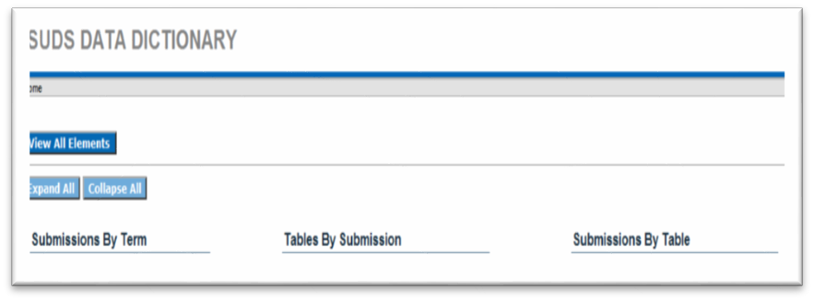

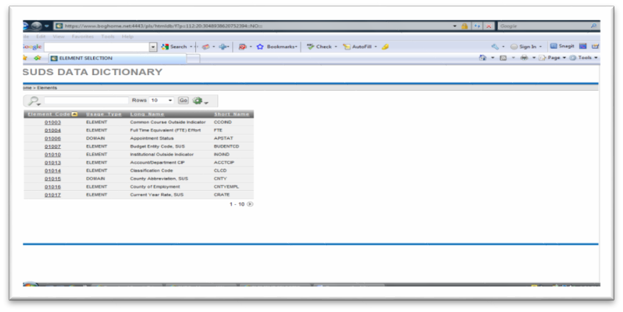

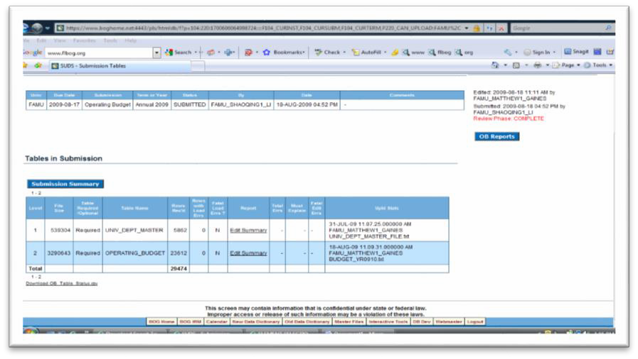
Appendix-1.

Bad Data Contents that could occur as it relates to the Account chartfield. In this example, and at the time, there was no appropriation category and revenue type values assigned to this account/object code on the Chartfield Attributes page. The screenshot below is subsequent to the error being corrected. Account attributes and attribute values are fields that are being used to map iRattler accounts to State standard values for meeting State reporting requirements – such as state appropriation categories, state standard object codes and revenue types, when applicable.

*** ERROR: APPRO_CATEGORY NOT ON PS_CF_ATTRIB_TBL FOR ACCOUNT 604097*
*** ERROR: REVENUE_TYPE NOT ON PS_CF_ATTRIB_TBL FOR ACCOUNT *

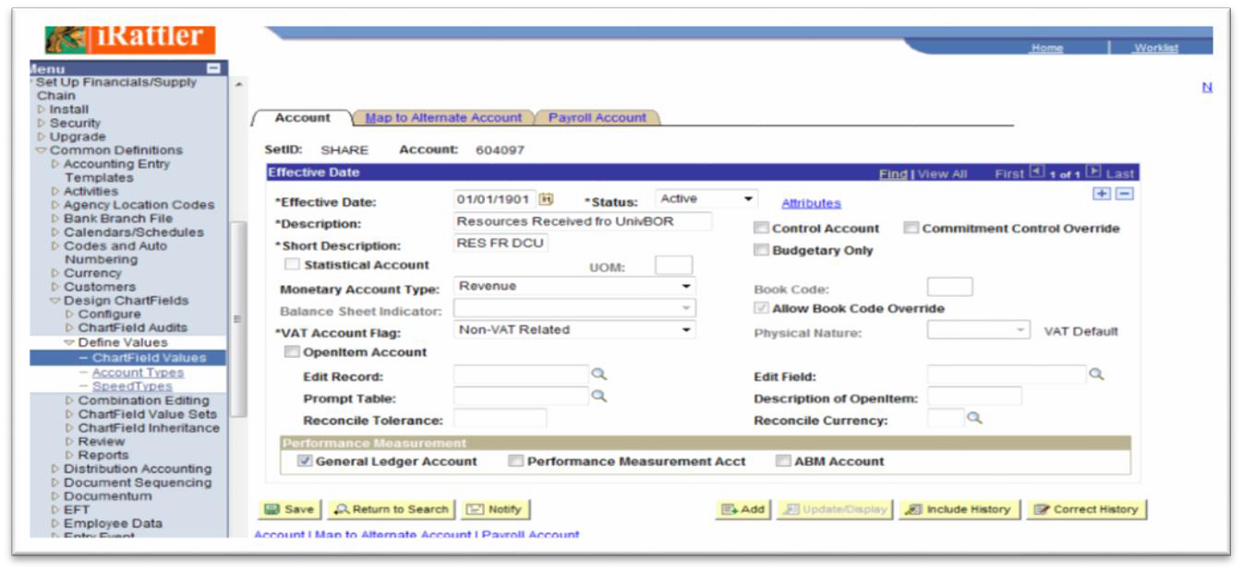

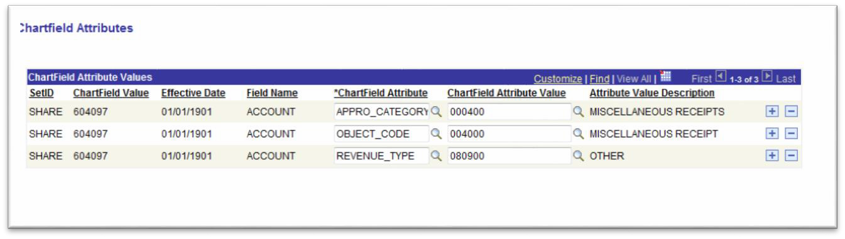

Appendix-2

Bad Data Contents that could occur as it relates to the Expansion Option file. In this example, and at the time the error occurred, transactions posted to this chartfield combination for department did not match the Expansion Option file values assigned to this department. The program used to extract data from the iRattler system to SUDS database had to be modified to look at the Expansion Option table for the correct values.

*** ERROR: SUS BUDGET ENTITY NOT ON PS_FAM_EO_EXPN TABLE FOR FUND 901*, DEPT. 550100*, PROJECT_ID *, PROGRAM_CODE 97*
*** ERROR: STATE FUND NOT ON PS_FAM_EO_EXPN TABLE FOR FUND 901*, DEPT. 550100*, PROJECT_ID
*, PROGRAM_CODE 97*
*** ERROR: FAMU FUND NOT ON PS_FAM_EO_EXPN TABLE FOR FUND 901*, DEPT. 550100*, PROJECT_ID
*, PROGRAM_CODE 97*
*** ERROR: STATE PROGRAM COMP. NOT ON PS_FAM_EO_EXPN TABLE FOR FUND 901*, DEPT. 550100*, PROJECT_ID *, PROGRAM_CODE 97*, $Prog-Comp 000000*

Expansion Option File
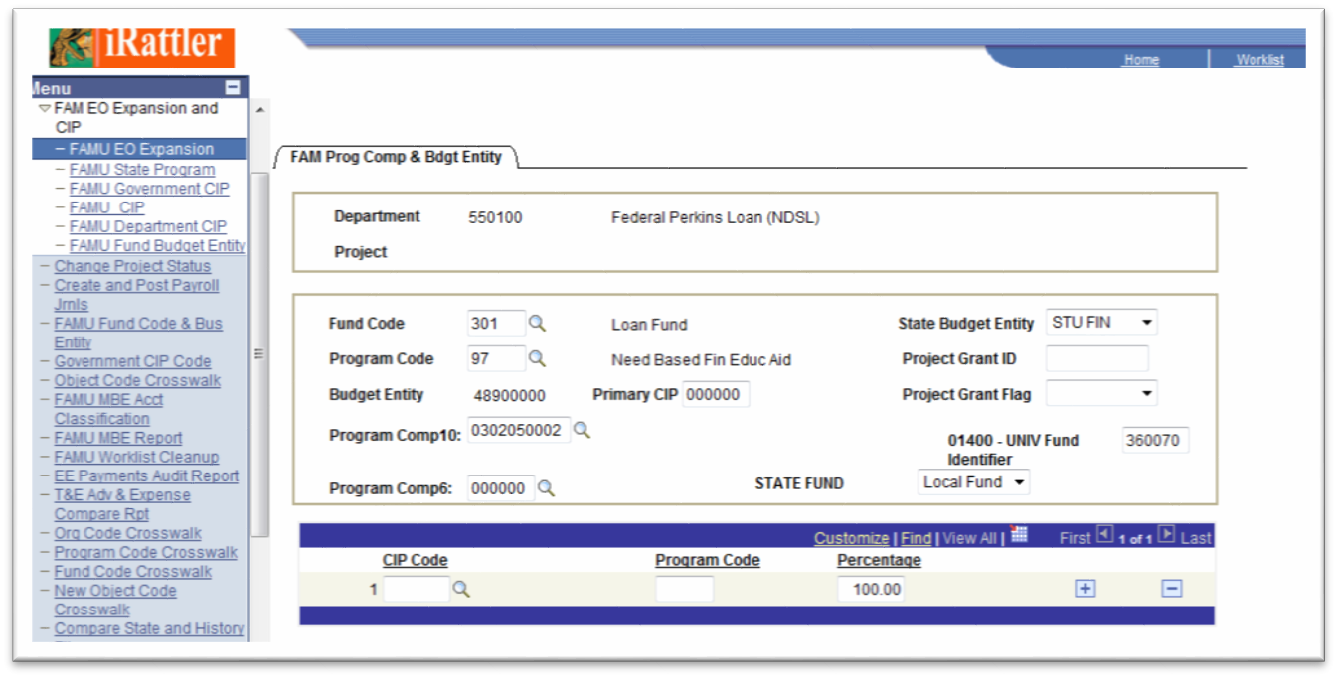

STEPS

- The university’s Data Administrator and ITS staff receive from the BOG’s Data Administrator the technical updates required for submission of the operating budget files.

- The Budget Office and the Controller’s Office conduct a review of the chart of accounts for required updates due to legislative and BOG requirements and university restructuring, additions and deletions of departments and other changes, and coordinates with ITS staff the implementation of system updates including ITS’s extract programs.

- The Budget Office and ITS staff agree on data environments to be used for HCMS salary category detail file data, confirms program updates including effective dates for extracting data from HCMS and data changes for FAMU/FSU College of Engineering employees not on FAMU’s payroll but included in FAMU’s operating budget

- The Budget Office adjusts history year positions and salary rate in HCMS to rate controls for each budget entity / fund / department as applicable. E&G positions and rate are as submitted on the Salary Category Detail File required to be submitted as of June 30.

- The Budget Office and the Office of Human resources corrects all errors and coordinates with ITS staff the finalization of data on the Board of Governors’ exhibits and schedules.

- The Controller’s Office in consultation with the Budget Office, finalizes prior year fund balances, receipts, revenues, transfers, expenditures and encumbrances. This final data is used as control totals to compare to reports generated by Board of Governors operating Budget software. The Budget Office coordinates with ITS staff to generate BOG’s reports. All errors are corrected and final PeopleSoft data is captured on the Board of Governors’ exhibits and schedules.

- Using the current year operating budget approved by the Board of Trustees and distributed in PeopleSoft to departments, ITS staff generates BOG’s reports as in “F” above. The Budget Office corrects all errors and finalizes the data to agree with operating budget control totals.

- The Budget Office with the assistance of Human Resources finalizes a file of current year positions and salary rate in HCMS to agree with operating budget controls for positions and salary rate.

- The following manually prepared Exhibits and Schedules are prepared for submission. The BOG’s Budget Office annually requests these schedules in writing. These are shown in Appendix A.

- E&G Schedule I

- Summary Schedule I (side-by-side for all budget entities)

- Fund Balance Summary

- Attachment III (Auxiliary Receipts from General Revenue sources)

- Supplemental Data Form I (Resource Utilization Deviations).

- Supplemental Data Form II (Student Services detail breakout).

- Tuition Differential Collections, Expenditures and Available Balances.

- When all data files are finalized and manually prepared exhibits and schedules are completed, the Budget Office requests ITS staff to make the files available to Office of Institutional Research (OIR) for review and submission to the BOG. Manually prepared exhibits and schedules are e-mailed to OIR for submission to the BOG.

3.7 Educational and General (E&G) Cash Distributions

Monies are electronically transferred to the university’s local bank account to cover E&G activities paid with General Revenue and Educational Enhancement Trust Fund (Lottery) allocations. These transfers are done by the Department of Education in accordance with predetermined schedules.

Budget Amendments/Transfers

Budget Amendments

The Board of Trustees Policy Number 2005-05 states that the President is hereby granted the authority to amend the approved operating budgets, provided that the amendments do not exceed 2% or $100,000 per fund. A budget report will be provided at each Board of Trustees meeting. Amendments approved in the previous fiscal year will be continued in the subsequent fiscal year if the obligation was not met and cash is certified as available. Budgets for E&G certified forward or non-E&G encumbrances do not require Board of Trustees re-approval as these expenditures were approved in the prior year’s budget. Changes in certified forward budget requirements will be reflected in the calculation of available carry forward monies. An electronic copy can be requested by contacting the Budget Office at 850.599.3270.

- A budget amendment is initiated at the Vice President/Director level.

- The Vice President/Director completes the budget amendment form.

- The form must include an explanation/justification for the change.

- Once completed, the Vice President/Director forwards the request to the Budget Office.

- The Budget Office reviews the request for compliance with policy guidelines and performs an analysis of the revenue and expenditures.

- The President reviews the amendment, if the President approves the amendment it is submitted to the Budget and Finance Committee with a recommendation for approval.

- The Budget and Finance Committee/BOT reviews the proposed amendment. If the request is denied, the transaction is not approved and the process ends. If the request is approved, the Budget Office is authorized to enter the amendment into the financial system.

- The Budget Office will maintain copies of all budget amendments as well as a copy of the minutes from the BOT meeting approving or denying the request.

Budget Transfers

A budget transfer is an internal transaction that transfers budget authority between departments or summary accounts within the same fund. These transactions do not change the bottom line revenue or expenditure budgets. Please refer to Exhibit B for a copy of the budget transfer form. An electronic copy can be requested by contacting the Budget Office at 850.599.3270 or from the Budget Office’s website.

    - A request for transfer is initiated at the Department level.

      - The Department completes the budget transfer form.

      - The form must include an explanation/justification for the change.

      - Once approved by the respective Vice President/Director, this form is forwarded to the Budget Office.

      - The Budget Office staff reviews the budget transfer request for compliance with the policy guidelines and to ensure that there are sufficient funds.

- If the transfer request complies with the policy guidelines and sufficient funds are available, the Budget Office processes the transfer in the Peoplesoft Financial System.

- A system report is generated to confirm budget actions have been properly reflected in the financial system.

- Once confirmed, the transaction is initialed by the budget analyst, signed by the Director and filed along with all supporting documentation.

- A copy of the approved transfer form is forwarded to the Vice President/Division Director/Department to let them know the transfer is completed.

- If the transfer request does not comply with policy guidelines and /or there are insufficient funds available, the transfer request is sent to the CFO with a staff recommendation to deny the request.

- If the CFO agrees with the staff recommendation, the Budget Office staff prepares a transmittal letter to the respective Vice President/Director/Department for the CFO’s signature.

- The Vice President/Director may appeal the denials to the CFO/Vice President for Administrative and Financial Services.

Budget Reporting/Monitoring

Quarterly Reporting/Monitoring

- The Budget Office will provide quarterly budget information to the President, the University Board of Trustees and the University Budget and Planning Council in order to detect shortfalls and/or overages in a timely manner, and to develop strategies for resolution.

- The Budget Office will obtain the data for both revenues and expenditures for all budget entities (Education and General, Contracts and Grants, Auxiliaries, etc.) from the PeopleSoft nVision reports.

- Analyze the actual revenue and expenditures, and detail any variances to the BOT-approved budget on a quarterly and year-to-date (YTD) basis.

- Currently, the University budgets on an annual basis. Therefore, quarterly budget allocation assumptions must be created for Revenues and Expenditures for all Summary Categories.

- Examples of these assumptions are Seasonal (40% Fall, 40% Spring, 20% Summer), Monthly (even distribution throughout the year); 25% each quarter, or some reasonable allocation methodology.

- Prepare a report of budget to actuals with supporting documentation, budget assumptions and footnotes.

- Section 1011.40(2), Florida Statues requires the President to provide written notification to the Board of Governors “if at any time the unencumbered balance in the education and general fund of the university board of trustees approved operating budget goes below 5 percent”. The Budget Office coordinates with the Controller’s Office to monitor expenditures and commitments to satisfy this requirement.

- Meet with the fiscal representatives and Vice Presidents to discuss quarterly reviews.

- Each Division/Department fiscal representative is required to do a quarterly review of revenues and expenditures of their respective areas.

Monthly Reporting/Monitoring

- The Budget Office will provide monthly budget reports to the President and UBPC from April to June in order to detect shortfalls and/or overages in a timely manner, and to develop strategies for resolution.

- Each Vice President is responsible for reviewing the division’s Budget-to-Actual PeopleSoft nVision report monthly.

- Vice Presidents are expected to use this information to monitor and manage their respective departments.

- The VPs are expected to work jointly with the Budget Office and their fiscal representatives to monitor actual and projected revenues and expenditures in order to detect shortfalls and/or overages in a timely manner, and to develop strategies for resolution.

- The Managers/Department Heads/Deans/Directors are responsible for reviewing their respective Budget-to-Actual PeopleSoft nVision reports on a more frequent basis and no less often than monthly.

- The monitoring and management of the departments is coordinated through the division Vice President.

Budget Checking

- Budget checking is the process that ensures that commitments and expenses do not exceed total budgets.

- In general, most transactions should not fail budget checking, especially at the beginning of the fiscal year when funds have not been expended.

- In the event a budget transfer is necessary, please refer to section 4.1 of this manual for instructions.

6.0 Required Reports and Data File Submissions

6.1 Operating Budget Files and Manual Exhibits and Schedules Refer to Section 3.7.
6.2 Expenditure Analysis File

Section 1011.90(4), Florida Statues requires that each university submit to the Board of Governors an Expenditure Analysis for the previous fiscal year ending June 30. The Expenditure Analysis consists of prior year E&G expenditures, positions, faculty activity information and student credit hours. The data generates a cost per student credit hour by academic discipline. There are two file sources of Expenditure Analysis data: Instruction and Research Data File and the Operating Budget File.

The Budget Office coordinates the preparation of this submission using university procedures for developing discipline costs and instructions and computer software provided by the Board of Governors. Below is a summary of the Expenditure Analysis procedures:

- The Office of Institutional Research prepares the Instruction and Research Data (IRD) File.

- Once the IRD file is completed, the Budget Office requests ITS to prepare an updated Operating Budget Extract File using the IRD file, history year Operating Budget Files and the Expansion Option file. Expenditure Analysis (EA) reports are also requested at this time for further analysis.

- When the EA reports are received, the Budget Office compares the credit hours on the EA reports to the credit hours from Student Data Course File reports. The Budget Office coordinates with Office of Institutional Research to reconcile any differences and make corrections as needed.

- Next the Budget Office uses the Student Data Course File 6A reports to prepare the Schedule of Fundable student credit hours by discipline and calculate the percentage that each discipline represents of the total credit hours.

- EA reports are used to prepare a schedule of Academic person years (paid from salaries and benefits and OPS) by discipline, and calculate the percentage that each discipline represents of the total person years.

- A determination is made as to which set of percentages (credit hours or academic man-years) will provide the most accurate distribution of totals costs among disciplines. The Expansion Option file is updated accordingly with the new percentages.

- For Instruction and Research departments with costs associated with specific disciplines, academic person year percentages are used to update departments as appropriate. The Nursing program is the only program that requires identification in the EA at the four-digit CIP level.

- To obtain data required for the Nursing program, OIR provides a report of academic person years for the Health Sciences discipline broken down by four-digit CIP codes. This data is used to distribute costs for the Nursing program.

- All other departments must be reviewed to determine necessary changes to the Expansion Option file.

- When the Expansion Option file is completed, EA reports are re-run and analyzed as required per BOG instructions. Corrections are made as appropriate.

- The Budget Office will review all BOG published reports and make revisions as required to finalize file.

- Upon finalization, the Budget Office will release the completed file to the Office of Institutional Research for an internal review before it is submitted to the BOG.

6.3 Salary Category Detail (SCD) Files

The purpose of the SCD files is to collect information regarding the number of person years and employment cost to the state from the institutions within the State University System (SUS). The information also serves as the repository for employee classification and demographic information across the SUS. This information will provide data to the Education Date Warehouse, the Governor and Legislature, and is used in the development of the SUS budget request, and the annual Expenditure Analysis.

The Board of Governors requires this collection of data at least four times each year:
- For submissions accompanying the operating budget in mid- August, the Budget Office is required to submit all authorized vacant, filled and reserved employee resources.
- Mid-Fall and Mid-Spring submissions require all authorized filled employee resources and instructional OPS employees.
- At the end of the calendar year and fiscal year, only authorized vacant, filled and reserve employee resources in the E&G budget entity are required.
- There are times that other submissions may be requested.
Specifications of the scope are defined at the time of the request.

Employee resources consist of the following information: FTE, expenditure of university resource, and salary information. The Budget Office coordinates the preparation and submission of these files using instructions and software provided by the Board of Governors and university developed procedures.

6.4 Other Reports/Special Projects

In response to requests for special reports and information, the Budget Office prepares or coordinates the preparation of same as may be required.

7.0 Appropriated Salary Increases

Based on salary increase provisions and funds provided by the Legislature in the General Appropriations Act, the Board of Governors provides a budget amendment to the university for the funding required to implement the increases for E&G funded employees. The Budget Office distributes the funds to departments’ budgets as required to cover employees’ increases.

Salary increases for Non-E&G employees must be funded from the appropriate Non-E&G sources.

EXHIBITS

- Budget Calendar

- Budget Transfer and Amendment Form

- Board of Trustees Policy #2005-02 Financial Administration

- Board of Trustees Policy # 2005-05 Preparation and Submission of Budget

- Statutes Relating to the Operating Budget Process

Budget Calendar
EXHIBIT A
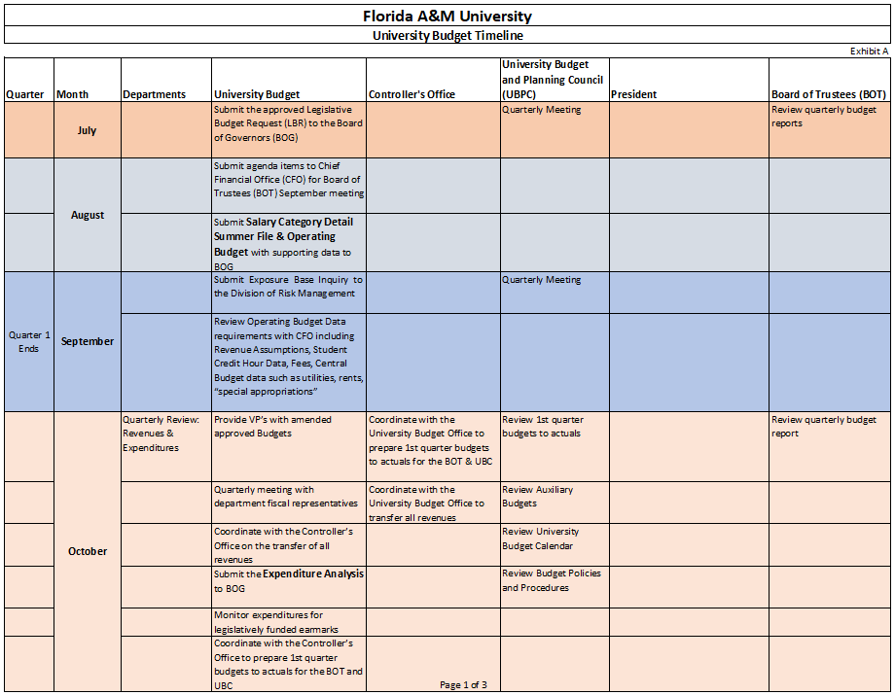

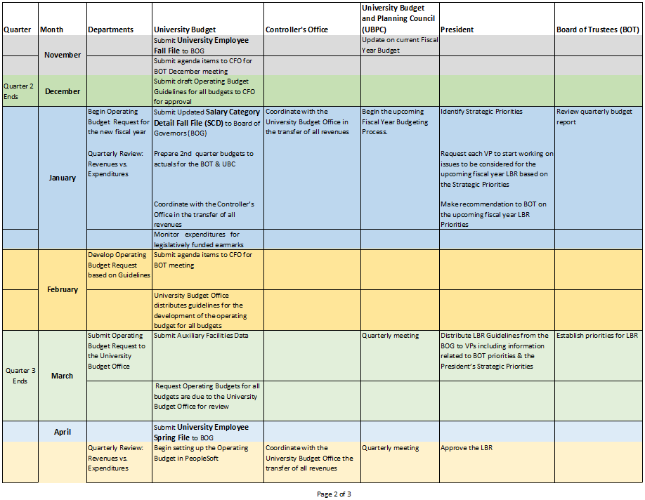
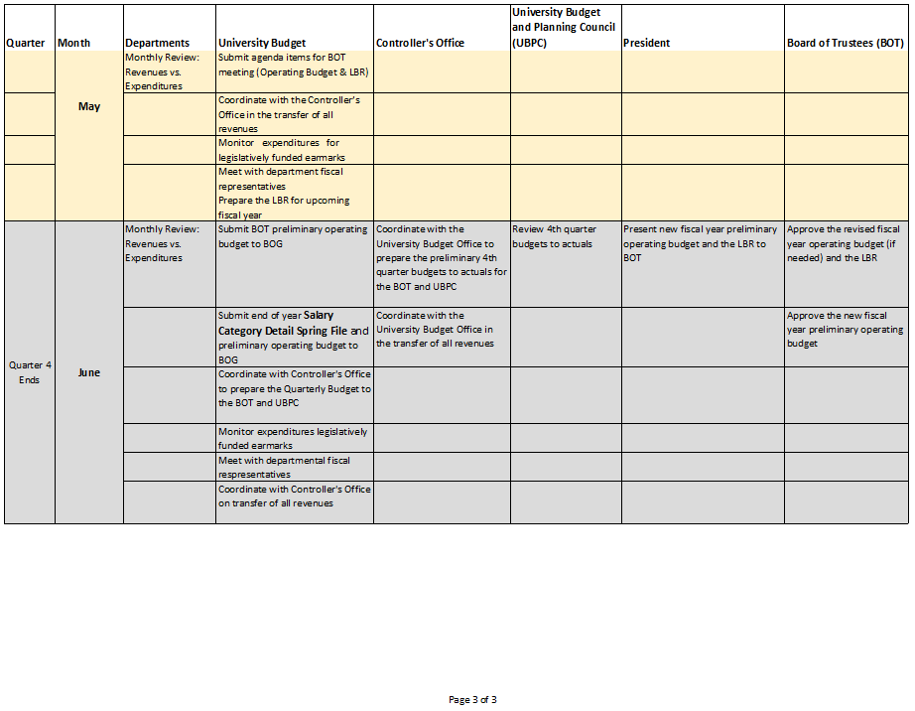
Request for Budget Transfer and Amendment
EXHIBIT B
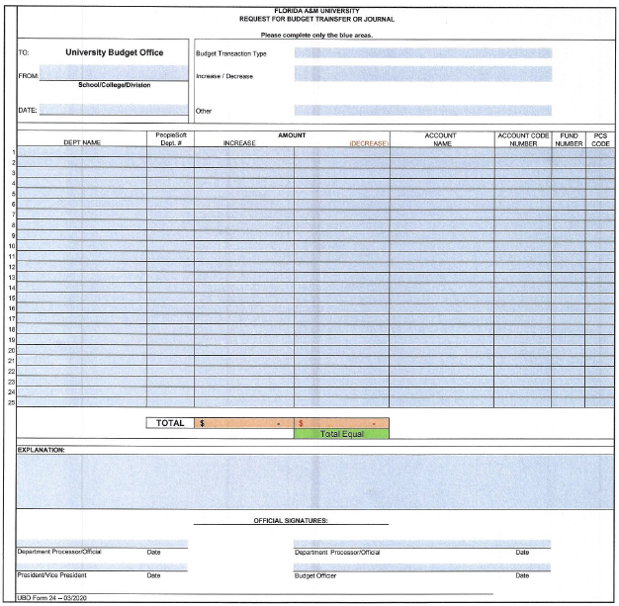

Revised FY 2007-08 (Budget Amendment Form)

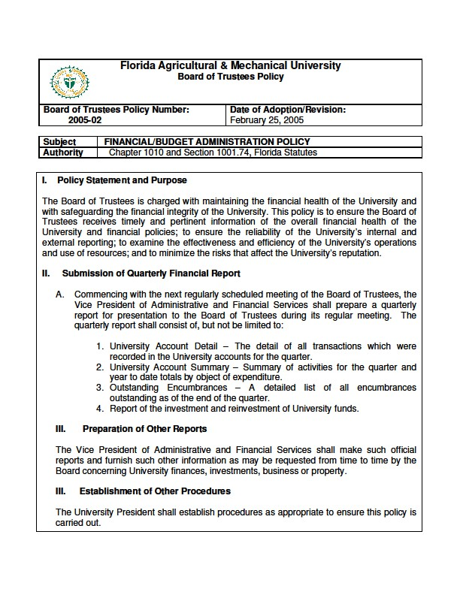
EXHIBIT C

EXHIBIT D
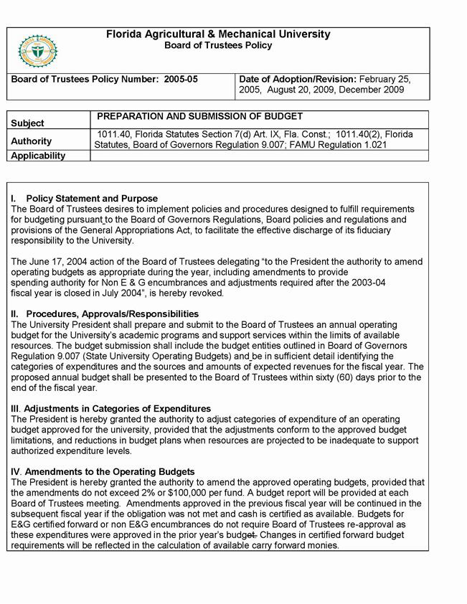

Statues Relating to the Operating Budget Process
EXHIBIT E

1. Powers and Duties of the University Board of Trustees (UBOT) | s.1001.74 (3) (a) (b) (c), Florida Statutes (F.S.)
2. System wide Data Collection | s. 1008.31 (4)
3. Definitions (Tuition & Out of State Fee) | s. 1009.01, F.S.
4. State University student fees | s. 1009.24, F.S.
5. Legislative capital outlay budget request | s. 1011.01, 1013.60 (1-3), F.S.
6. UBOT shall prepare, adopt, & submit to the Chancellor of the State University System for review an annual operating budget | s. 1011.40 (2), F.S.
7. Budget for Universities | s. 1011.40, F.S.
8. University Appropriations | s. 1011.41, F.S.
9. Trust Fund Dissolution and local Account appropriation | s. 1011.4106, F.S.
10. University depositories; deposits into & withdrawals from depositories | s. 1011.42, F.S.
11. Investment of University Agency & Activity Funds | s. 1011.43, F.S.
12. End of year balance of funds | s. 1011.45, F.S.
13. Auxiliary enterprises; contracts, grants & donations | s. 1011.47, F.S.
14. State University Funding | s. 1011.90, F.S.
15. Additional Appropriation | s. 1011.91, F.S.
16. Annual capital outlay budget | s. 1013.63 (4), F.S.
17. Funds for comprehensive educational plants needs | s. 1013.74 (4), F.S.
18. SUS Authorization for fixed capital outlay projects | s. 1013.74 (1-4), F.S.
19. Approval required for certain university related Facility acquisitions | s. 1013.78 (1-2), F.S.
20. University Facility Enhancement Challenge Grant | s. 1013.79

